FINAL PROJECT GERMAN LOAN BANK

**INTRODUCTION**

The banking sector, a cornerstone of the global economy, has always grappled with the challenge of predicting loan defaulters. As the digital age ushers in an era of data-driven decision-making, banks are increasingly looking to harness the power of data to mitigate risks and optimize operations. This project delves deep into the historical data of customers from a German bank to predict potential loan defaulters.

The dataset comprises 1,000 rows, each representing a unique customer, and 17 columns detailing various attributes such as `checking_balance`, `months_loan_duration`, `credit_history`, `purpose`, `amount`, `savings_balance`, `employment_duration`, `percent_of_income`, `years_at_residence`, `age`, `other_credit`, `housing`, `existing_loans_count`, `job`, `dependents`, `phone`, and the target column `default`.

Several pertinent questions arise in this context:

1. Can historical data provide a reliable framework to predict future loan defaults?
2. Which customer attributes or behaviors are most indicative of a potential loan default?
3. How do external economic factors, captured in the data, influence the likelihood of a default?
4. Are younger customers more prone to defaulting than older ones, and if so, why?
5. Does the purpose of the loan (e.g., housing, education, personal expenses) play a significant role in determining the default rate?
6. How does the duration of employment or the type of employment impact the probability of default?

By seeking answers to these questions, this project aims not only to build a predictive model but also to uncover the intricate relationships and patterns that underpin loan defaults. We will be answering these questions in the below sections.

**METHODS and MATERIALS**

Our analysis began with an in-depth Exploratory Data Analysis (EDA) on the German bank dataset. This dataset comprises various features such as employment duration, existing loans count, saving balance, and more, the below explains the statistics from the data.

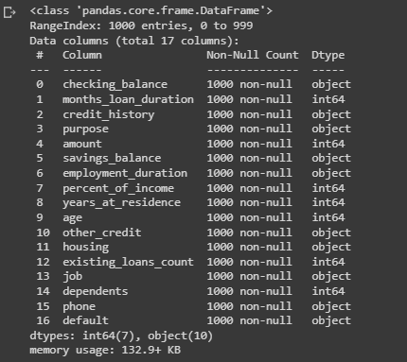

According to figure, the data contains no missing values and has 1000 rows and 17 fields.

This indicates there is no requirement to impute any missing values and can be proceeded further.

After that a statistical summary of the numerical columns is checked as shown in next figure.

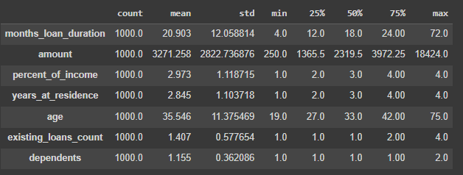

A preliminary statistical summary of the numerical columns reveals the following insights:

1. months_loan_duration ranges from 4 to 72 months, with an average duration of approximately 20.9 months.
2. The amount column, representing the loan amount, has values ranging from 250 to 18,424, with an average loan amount of approximately 3,271.
3. Customers, on average, dedicate about 2.97% of their income towards loan repayment.
4. The average age of customers in the dataset is approximately 35.5 years, with the youngest being 19 and the oldest 75.
5. On average, customers have around 1.4 existing loans, with some having as many as 4.
6. The years_at_residence column indicates that customers have lived in their current residence for an average of 2.8 years, with a range from 1 to 4 years.
7. The dependents column shows that customers have an average of 1.15 dependents, with a maximum of 2.

To ensure the dataset's integrity and consistency, several preprocessing steps were undertaken:

**Data Imputation:**

In the dataset, any instance where the purpose is mistakenly labeled as "car0" has been corrected to "car".

**Label Encoding:**

The dataset contains several categorical columns. For the purpose of analysis and modeling, these categorical values needed to be converted into a numerical format. This was achieved using label encoding. Label encoding is a technique where each unique category in a column is assigned a unique integer.

**Univariate Visualizations:**

Univariate Visualizations unveils the distribution and patterns within a single variable, aiding in understanding its individual characteristics and anomalies. As part of this histograms were shown as below figures for all the numerical columns. Histograms provide a visual summary of the distribution of numerical data, allowing businesses to identify patterns, outliers, and central tendencies, which are crucial for understanding customer behaviors and making data-driven decisions.

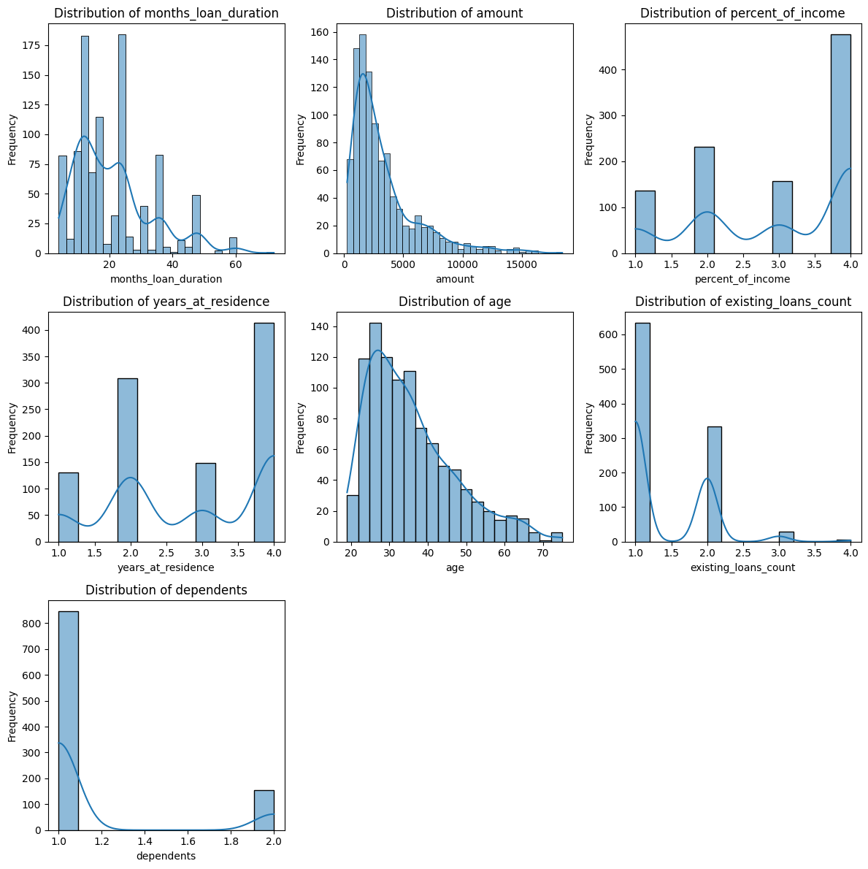

Below are the observations –

1. Majority customers have a loan duration of <25 months with the data being right skewed.
2. Amount of loan is also right skewed to the right with most of the loan within

3500DMs.

1. Similarly, most of the customers either pay 2% or 4% of the disposable income towards the

repayment of loan. This data is left skewed.

1. Maximum customers are residing at their current residence for 2 or 4 years. This data

is left skewed.

1. Maximum customers borrowing loans are younger and the data is skewed.
2. Maximum customers borrowing have at least 1 loan account and very minimal customers.

have 4 accounts. The data is right skewed.

1. Maximum customers have 1 dependent and very few have 2 dependents.

After exploring numerical columns, we go to categorical columns with Count plots. Count plots offer a visual representation of the distribution of different categories, helping businesses gauge the prevalence of specific attributes and make informed decisions based on their frequency.

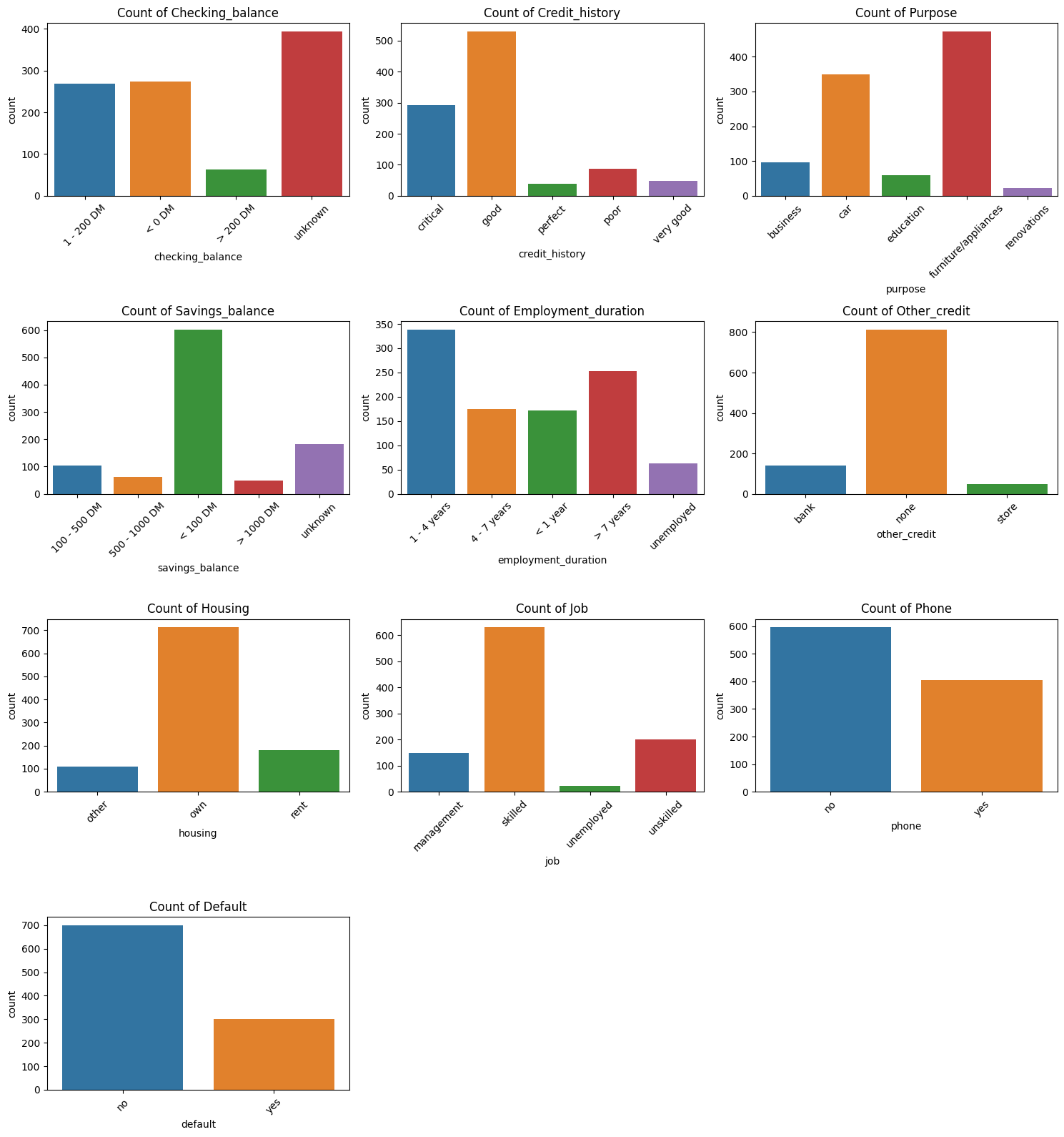

1. Majority of customers have an "unknown" checking balance (394), followed closely by those with "< 0 DM" (274) and "1 - 200 DM" (269), while a smaller segment possesses a balance of "> 200 DM" (63).
2. The 'good' credit history is most prevalent with 530 individuals, while 'perfect' is least common with 40 individuals.
3. Most loans (473) are for 'furniture/appliances', while only 22 are for the ‘renovations’ purpose.
4. A majority have savings balance '< 100 DM' (603), and the least common category is '> 1000 DM' with 48 individuals.
5. '1 - 4 years' is the most common employment duration (339) whereas 'unemployed' is least common with 62 individuals.
6. A vast majority of individuals (814) have 'none' as their other credit. The 'store' credit is least common with 47 individuals.
7. The majority (713) own their housing, while 108 have 'other' types of housing.
8. Most individuals (630) have a 'skilled' job, while only 22 are 'unemployed'.
9. 596 individuals have no phone, while 404 have one.
10. 700 individuals have not defaulted (no), whereas 300 have (yes).

**Question:** Can historical data provide a reliable framework to predict future loan defaults?

**Answer:** Yes, historical data offers a foundation for predicting loan defaults.

**Bivariate Visualizations**

Bivariate Visualizations explores the relationship between two variables, revealing patterns, correlations, or potential causations. As part of this, we have box plots which illustrate how key financial and demographic attributes, such as loan duration, loan amount, income percentage, years of residence, age, existing loan count, and number of dependents, vary between customers who defaulted and those who did not. Insights from these plots can guide targeted interventions and risk assessments.

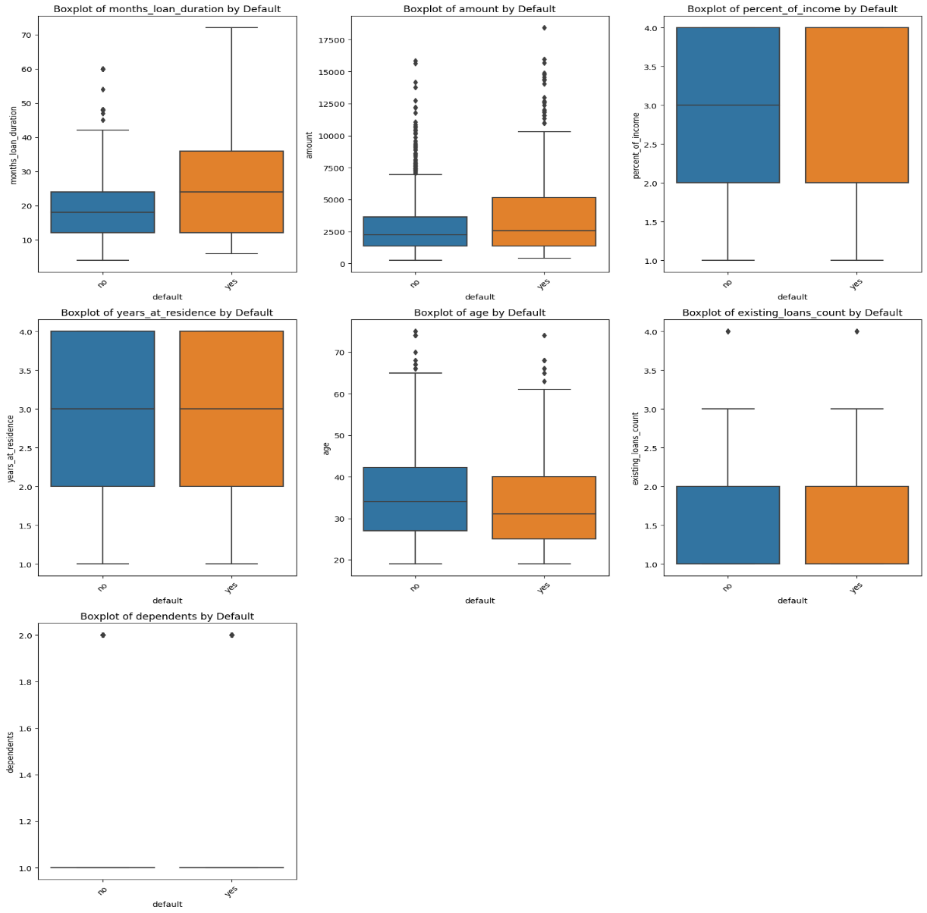

With the above plots we find that customers with age groups between 25-39 having higher loan amounts and having more loan duration in months are generally defaulting.

**Question:** Are younger customers more prone to defaulting than older ones, and if so, why?

**Answer:** Younger customers, especially those in their late twenties to late thirties, seem more prone to defaulting.

Then we have stacked bar plots which provide a consolidated view of the proportion of defaults across different categorical segments, enabling businesses to identify high-risk groups and tailor their strategies accordingly.

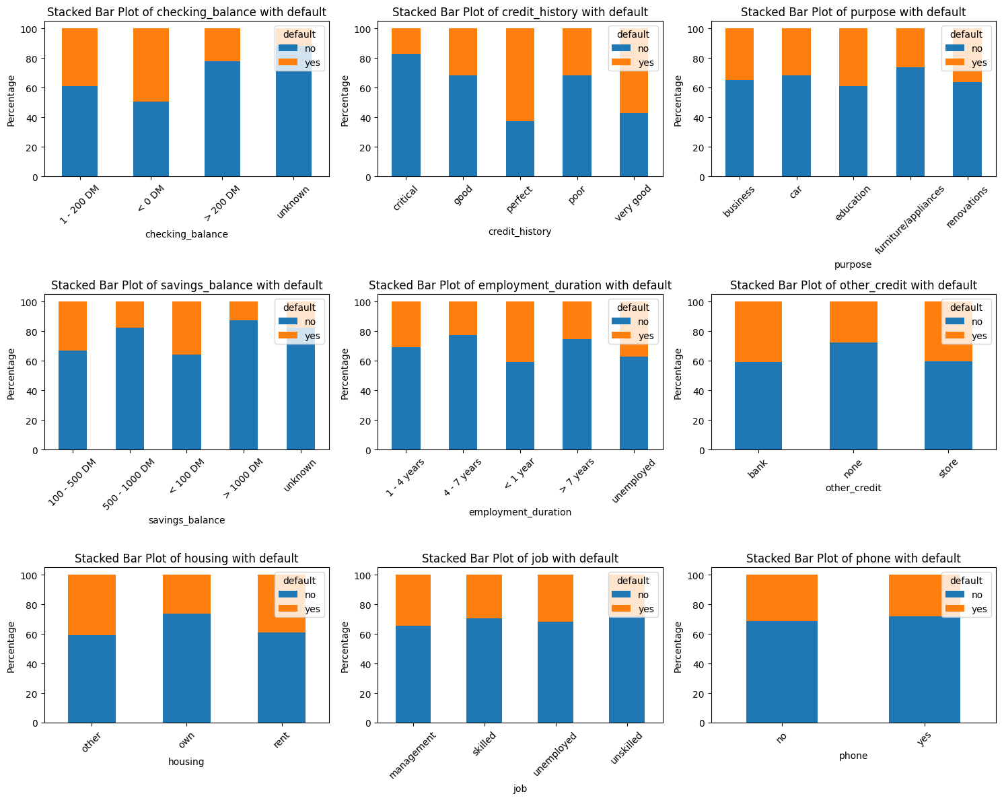

The above plots illustrate the relationship between the default status and various categorical attributes. From a business perspective, it is noteworthy that customers with a checking balance of less than 200DM, residing in rented accommodations or other non-owned properties, and maintaining a savings balance of less than 500DM seem to have a higher likelihood of defaulting. Interestingly, customers with a 'perfect' credit history also fall into this higher risk category. This observation might seem counterintuitive at first. However, considering the limited dataset, where only about 40 customers have a perfect credit history, it is prudent to approach this insight with caution before drawing definitive conclusions.

**Question:** Does the purpose of the loan (e.g., housing, education, personal expenses) play a significant role in determining the default rate?

**Answer:** The purpose, especially loans for education, businesses and renovations might influence the default rate.

**Question:** Which customer attributes or behaviors are most indicative of a potential loan default?

**Answer:** High Credit scores, negative checking balance, and less experienced customers are indicative attributes.

**Question:** How does the duration of employment or the type of employment impact the probability of default?

**Answer:** Shorter employment durations and specific job types might influence the default probability.

**Multivariate Visualizations**

Multivariate Visualizations analyzes interactions among multiple variables simultaneously, offering a comprehensive view of complex data relationships. To find the correlations we have used heatmap, correlation matrix and pair plot to achieve this.

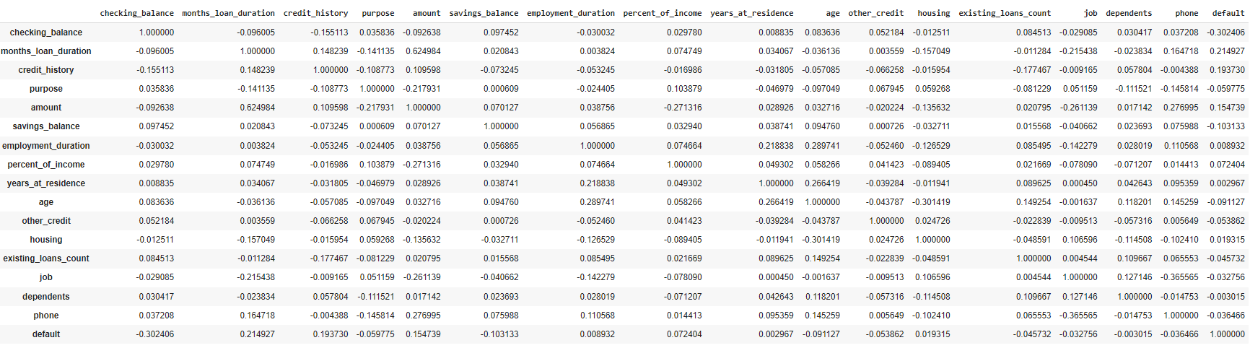

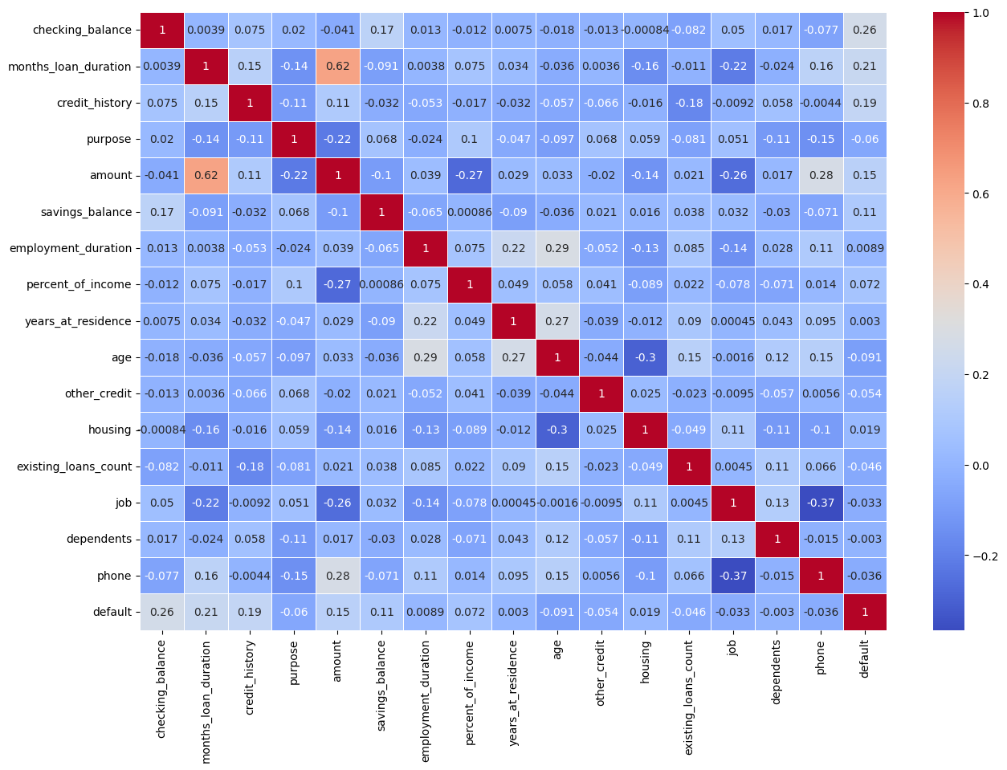

Correlation Matrix shows a numerical representation that quantifies the linear relationships between variables, aiding in identifying patterns and multicollinearity in datasets. While heat Map graphically represents data values using color gradients, enabling quick identification of patterns and correlations across variables. Pair Plots visualize pairwise relationships across multiple variables in a dataset, offering a holistic view of their distributions and correlations.

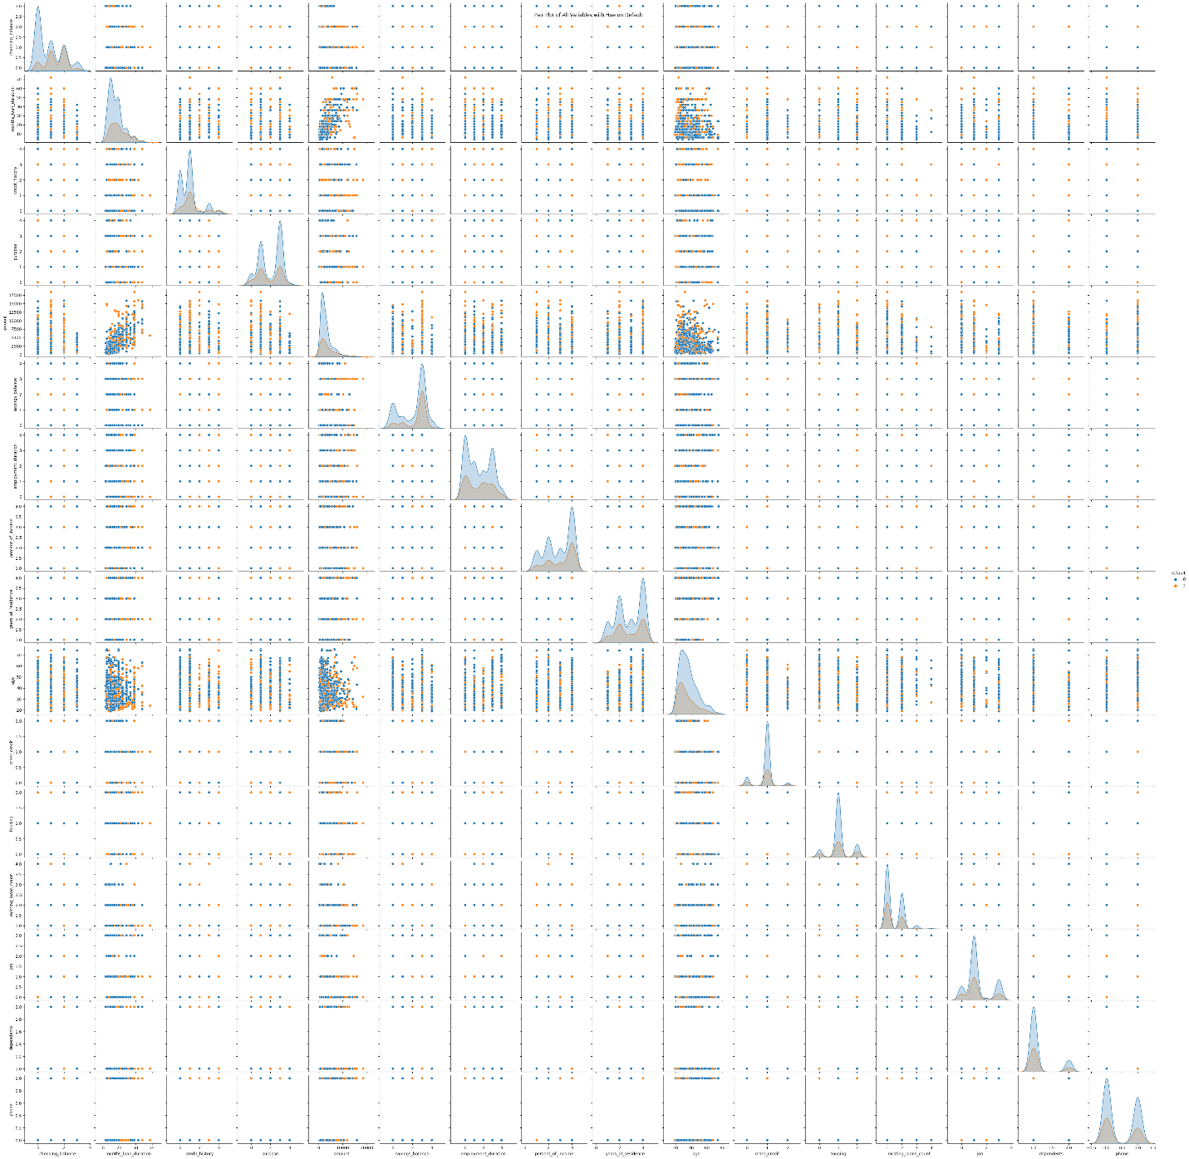

So here we see that the moderate customers with positive correlation between loan amount and duration in months and have strong negative correlation between Job and Phone.

**Question:** How do external economic factors, captured in the data, influence the likelihood of a default?

**Answer:** The dataset focuses more on individual attributes than broader external economic factors.

**Model Building and Selection**

In the realm of banking, predicting loan defaulters is of paramount importance. The ability to accurately predict whether a customer will default on their loan can significantly impact a bank's profitability and risk management strategies. With this business perspective in mind, the project embarked on building predictive models using various algorithms to ensure the best possible accuracy. In the context of our banking project, before deploying any predictive model, it is crucial to ensure that our data is well-prepared. We've transformed our categorical data into a format that our model can understand using encoding techniques. To validate the performance of our model, we have divided our dataset into two parts: training and testing, with an 80:20 ratio. This ensures that our model learns from 80% of the data and is then tested on the remaining 20% to gauge its real-world performance. Lastly, to ensure that all features contribute equally to the model's performance, we have scaled our data, ensuring no single feature disproportionately influences the model due to its scale.

**Diverse Algorithms:**

Multiple machine learning algorithms were employed to ensure robustness in prediction. The algorithms include Decision Trees, Random Forests, Gradient Boosting Machines, AdaBoost, XGBoost, LightGBM, and CatBoost. Each of these algorithms has its strengths and nuances, making them suitable for different types of data distributions and patterns.

**Model Evaluation:**

Each model was rigorously trained and validated. The performance metrics used include accuracy, recall, precision, and F1-score. From a business standpoint, these metrics provide insights into how well the model can predict actual defaulters (recall) and how often its predictions are correct (precision).

**Hyperparameter Tuning:**

For all algorithms, hyperparameter tuning was conducted to optimize the model's performance. This is analogous to fine-tuning a strategy in the business world to achieve the best results.

The model-building phase was approached with a blend of technical rigor and business acumen. The goal was not just to achieve high accuracy but also to build a model that can be trusted and integrated into the bank's decision-making process, ensuring both profitability and customer trust.

**RESULTS**

After building the models and predicting the default status, 7 different algorithms provide different results.

We get the following Metrics –

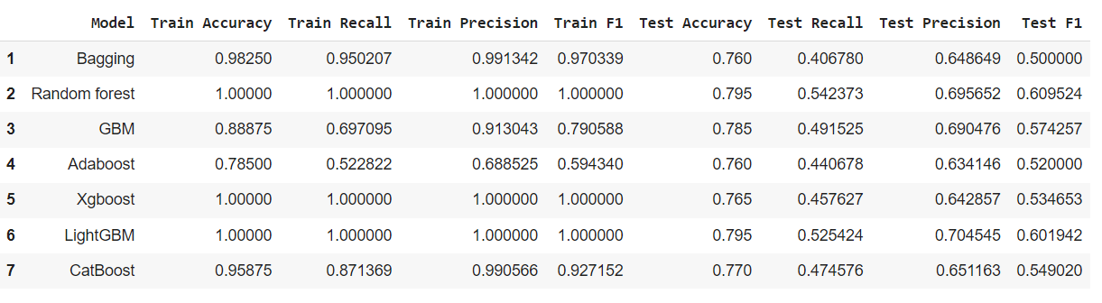When the 7 models are cross-validated and trained on train data set, below are results –

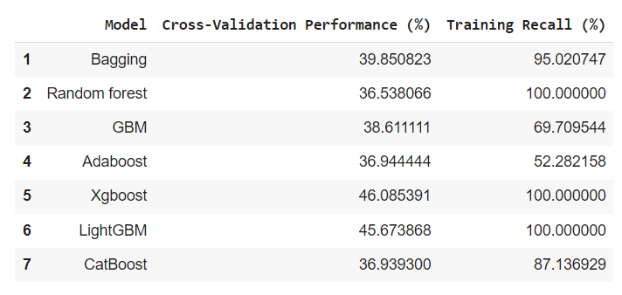

Looking at the results of 7 models, GBM and AdaBoost might require hyperparameter tuning as they have less recall compared to other models.

Now while hyperparameter tuning we are taking the below parameters with best parameters in Grid CV. The below table also lists the CV scores obtained after fitting each model.

|  |  |  |  |  |
| --- | --- | --- | --- | --- |
| **index** | **Model Name** | **Parameters** | **Best Parameters** | **CV Score** |
| **1** | GradientBoostingClassifier | {'n_estimators': [10, 20, 30, 40, 50, 60, 70, 80, 90, 100], 'learning_rate': [0.1, 0.2, 0.3, 0.4, 0.5, 0.6, 0.7, 0.8, 0.9], 'max_depth': [1, 2, 3]} | {'learning_rate': 0.8, 'max_depth': 2, 'n_estimators': 100} | 0.526870748 |
| **2** | AdaBoost | {'n_estimators': [10, 20, 30, 40, 50, 60, 70, 80, 90, 100], 'learning_rate': [0.1, 0.01, 0.2, 0.05, 1], 'base_estimator': ['DecisionTreeClassifier(max_depth=1)', 'DecisionTreeClassifier(max_depth=2)', 'DecisionTreeClassifier(max_depth=3)']} | {'base_estimator': 'DecisionTreeClassifier(max_depth=3, random_state=1)', 'learning_rate': 1, 'n_estimators': 30} | 0.489540816 |
| **3** | XGBClassifier | {'n_estimators': [50], 'scale_pos_weight': [2, 5], 'learning_rate': [0.1, 0.2, 0.3, 0.4, 0.5, 0.6, 0.7, 0.8, 0.9], 'gamma': [0, 1, 3, 5], 'subsample': [0.8, 0.9, 1], 'max_depth': [1, 2, 3], 'reg_lambda': [5, 10]} | {'gamma': 0, 'learning_rate': 0.1, 'max_depth': 1, 'n_estimators': 50, 'reg_lambda': 10, 'scale_pos_weight': 5, 'subsample': 1} | 0.90042517 |
| **4** | RandomForest | {'n_estimators': [10, 20, 30, 40, 50, 60, 70, 80, 90, 100], 'max_depth': [1, 2, 3, 4], 'max_features': [1, 2, 3, 4, 5, 6, 7, 8, 9, 10, 11, 12, 13, 14]} | {'max_depth': 4, 'max_features': 12, 'n_estimators': 70} | 0.352721088 |
| **5** | CatBoost | {'iterations': [500], 'depth': [4, 5, 6], 'learning_rate': [0.01, 0.05, 0.1], 'l2_leaf_reg': [1, 3, 5, 7, 9]} | {'depth': 6, 'iterations': 500, 'l2_leaf_reg': 1, 'learning_rate': 0.05} | 0.48962585 |
| **6** | Bagging | {'n_estimators': [50, 100], 'max_samples': [0.5, 0.8, 1.0], 'max_features': [0.5, 0.8, 1.0], 'bootstrap': [True, False], 'bootstrap_features': [True, False]} | {'bootstrap': False, 'bootstrap_features': False, 'max_features': 1.0, 'max_samples': 1.0, 'n_estimators': 50} | 0.485714286 |
| **7** | LightGBM | {'n_estimators': [50, 100, 150], 'max_depth': [4, 5, 6, -1], 'learning_rate': [0.01, 0.05, 0.1], 'num_leaves': [20, 31, 40], 'boosting_type': ['gbdt', 'dart'], 'reg_alpha': [0, 0.1, 0.5], 'reg_lambda': [0, 0.1, 0.5]} | {'boosting_type': 'gbdt', 'learning_rate': 0.1, 'max_depth': -1, 'n_estimators': 150, 'num_leaves': 31, 'reg_alpha': 0.1, 'reg_lambda': 0.5} | 0.485544218 |

After Hyperparameter tuning we get the following Confusion Matrices for the 7 models -

Confusion matrices for the 7 models after tuning are shown below:

1. **GBM Classifier**

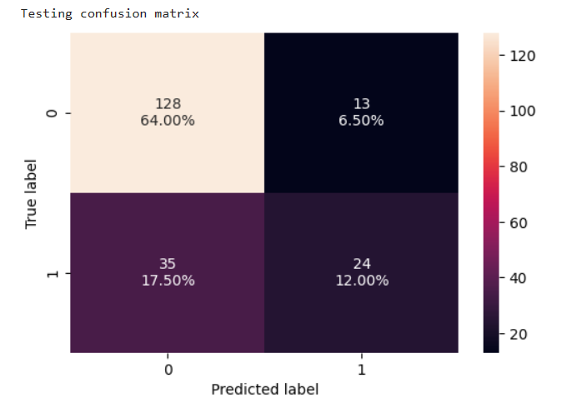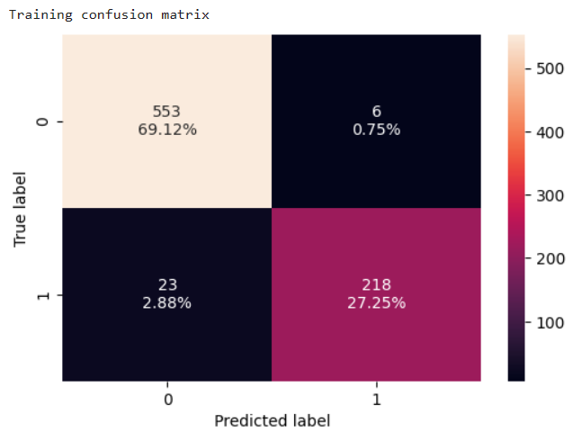

1. 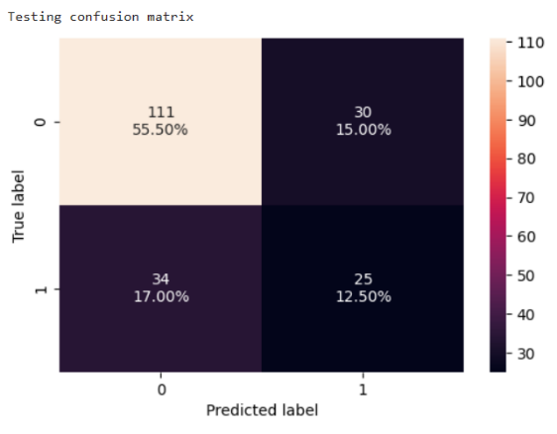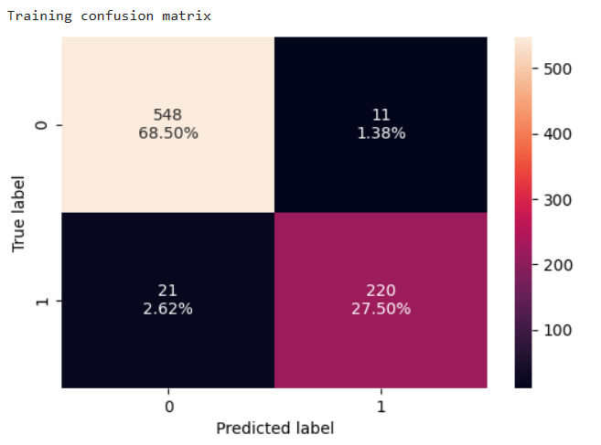 **AdaBoost Classifier**
2. 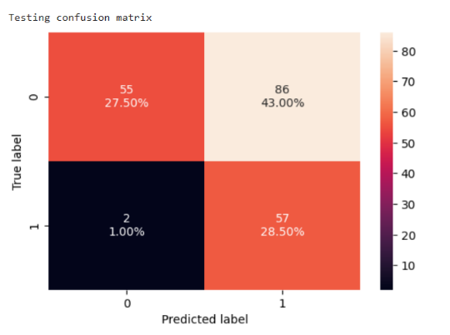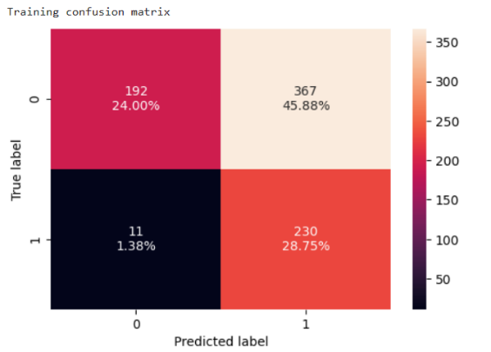 **XGBoost Classifier**
3. **Random Forest Classifier**

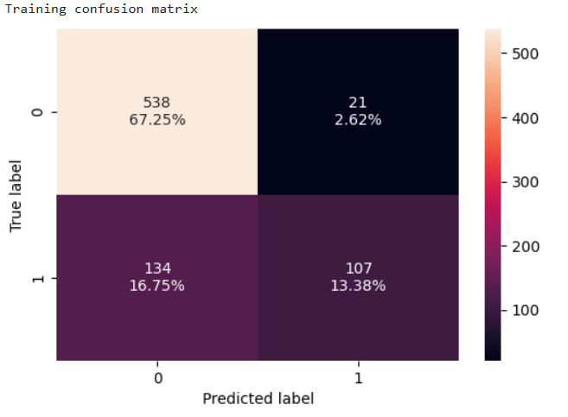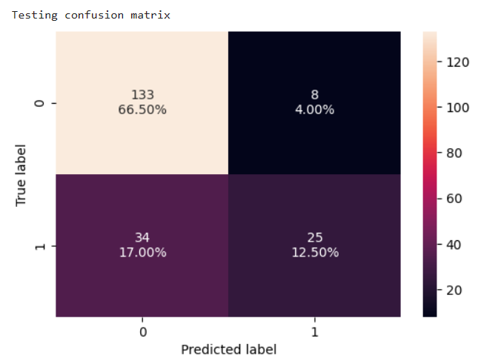

1. 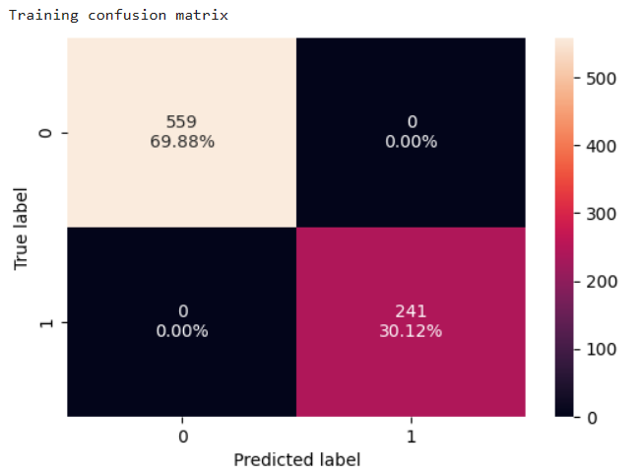**Cat Boost Classifier**

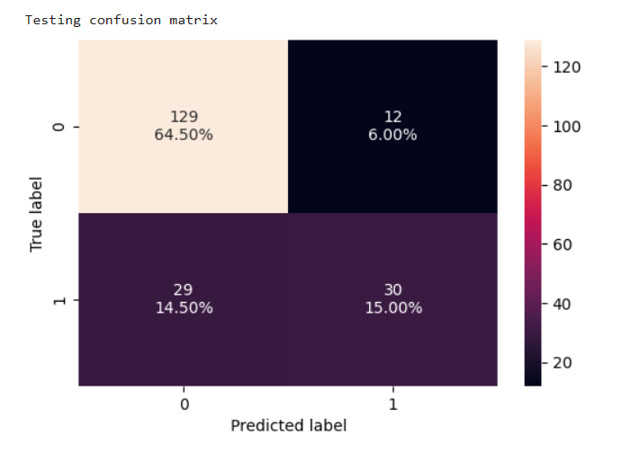

1. **Bagging Classifier**

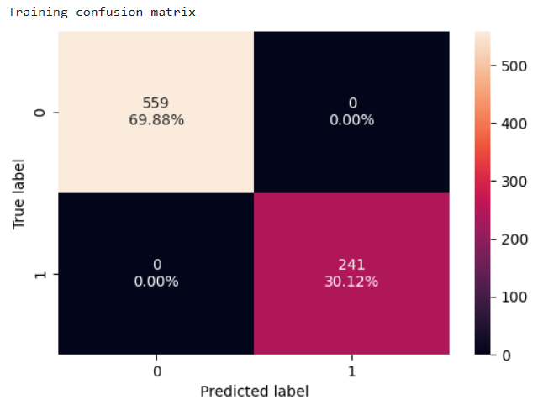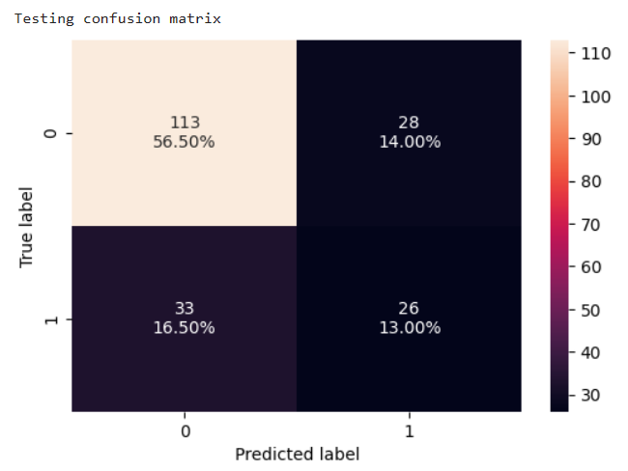

1. **Light GBM Classifier**

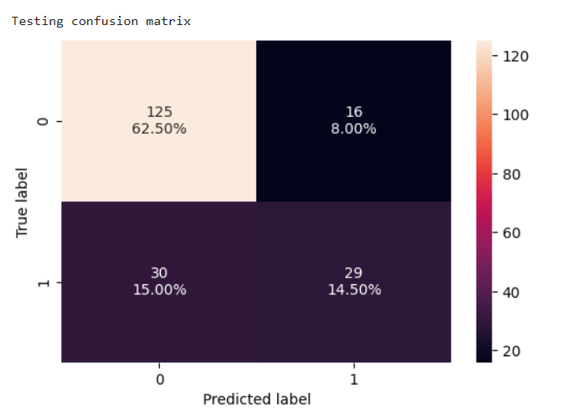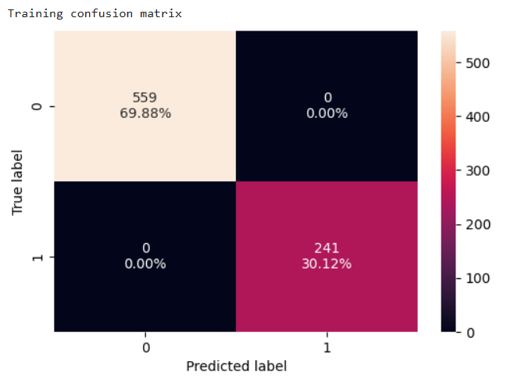

Now after tuning we get the below comparisons of metrics for all the models for Train and Test –

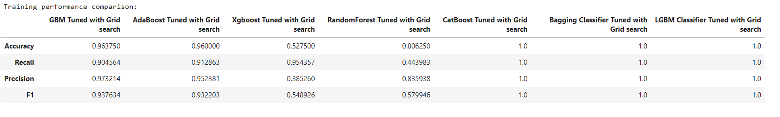

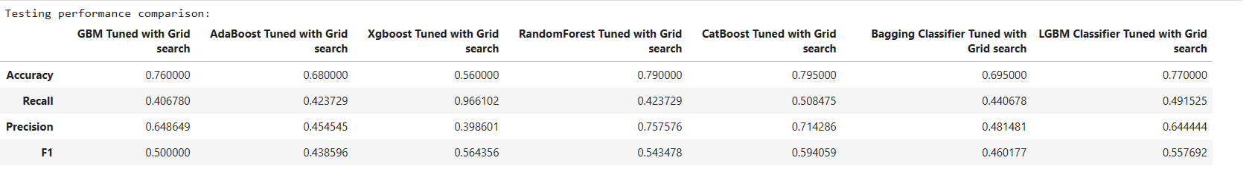

Now upon comparison of the Recall before and after tuning we get the below results for the different models -

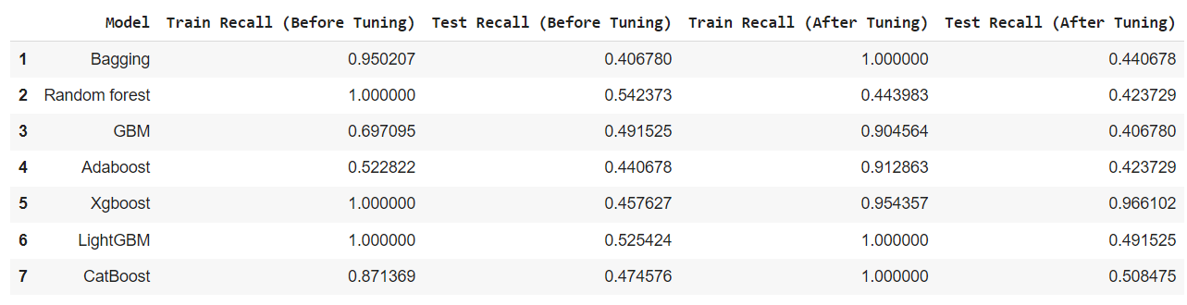

**DISCUSSIONS**

**Summary of Major Findings:**

We employed seven different machine learning models to predict the default status. Before hyperparameter tuning, certain models, notably Random Forest and Xgboost, exhibited perfect recall on the training set but not on the test set. After the tuning process, there was a significant improvement in recall for most models on the training set. For instance, the GBM's recall jumped from 69.71% to 90.46%. However, the test results post-tuning was mixed. While Xgboost showed a remarkable improvement, with its test recall surging to 96.61%, GBM's performance dipped slightly to 40.68%.

**Interpretation and Explanation of Results:**

The discrepancy between training and test performance in models like Random Forest and Xgboost before tuning suggests a possible overfitting scenario. Hyperparameter tuning, while beneficial in refining a model's performance on the training set, does not always guarantee better generalization to unseen data. This was evident in our results where, despite the impressive recall figures for Xgboost post-tuning, GBM's performance on unseen data was not as commendable. This underscores the importance of ensuring that our models generalize well and do not just memorize the training data.

**Limitations and Future Directions:**

A significant limitation of our approach was the potential over-reliance on recall as the primary metric. While recall is crucial, especially in scenarios where the cost of false negatives is high, it's essential to consider other metrics. Future studies might look at balancing precision and recall, possibly focusing on the F1 score, to ensure the model doesn't over-predict the default cases. There's also room to explore other modeling techniques. Ensemble methods or neural networks could be potential avenues to further improve prediction accuracy and generalization.

**CONCLUSIONS**

In our comprehensive analysis of predicting loan defaulters using the German bank dataset, we found that machine learning models, when fine-tuned, can offer valuable insights into potential default risks. While some models, like Xgboost, demonstrated promising results post-tuning, others, such as GBM, highlighted the challenges of ensuring consistent performance across both training and test datasets. The study underscores the importance of not solely relying on a single metric like recall but considering a holistic set of metrics to ensure the model's robustness. The intricate relationships and patterns unearthed from this dataset emphasize the potential of data-driven approaches in the banking sector. As a key takeaway, while machine learning offers powerful tools for prediction, it is imperative to approach modeling with both technical rigor and a deep understanding of the business context to ensure actionable and reliable insights.